1. 
2. 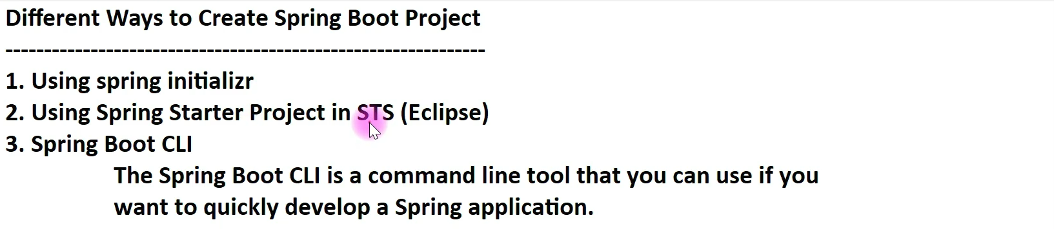
3. 
4. By using plugin, we can integrate this in IDE too.
5. 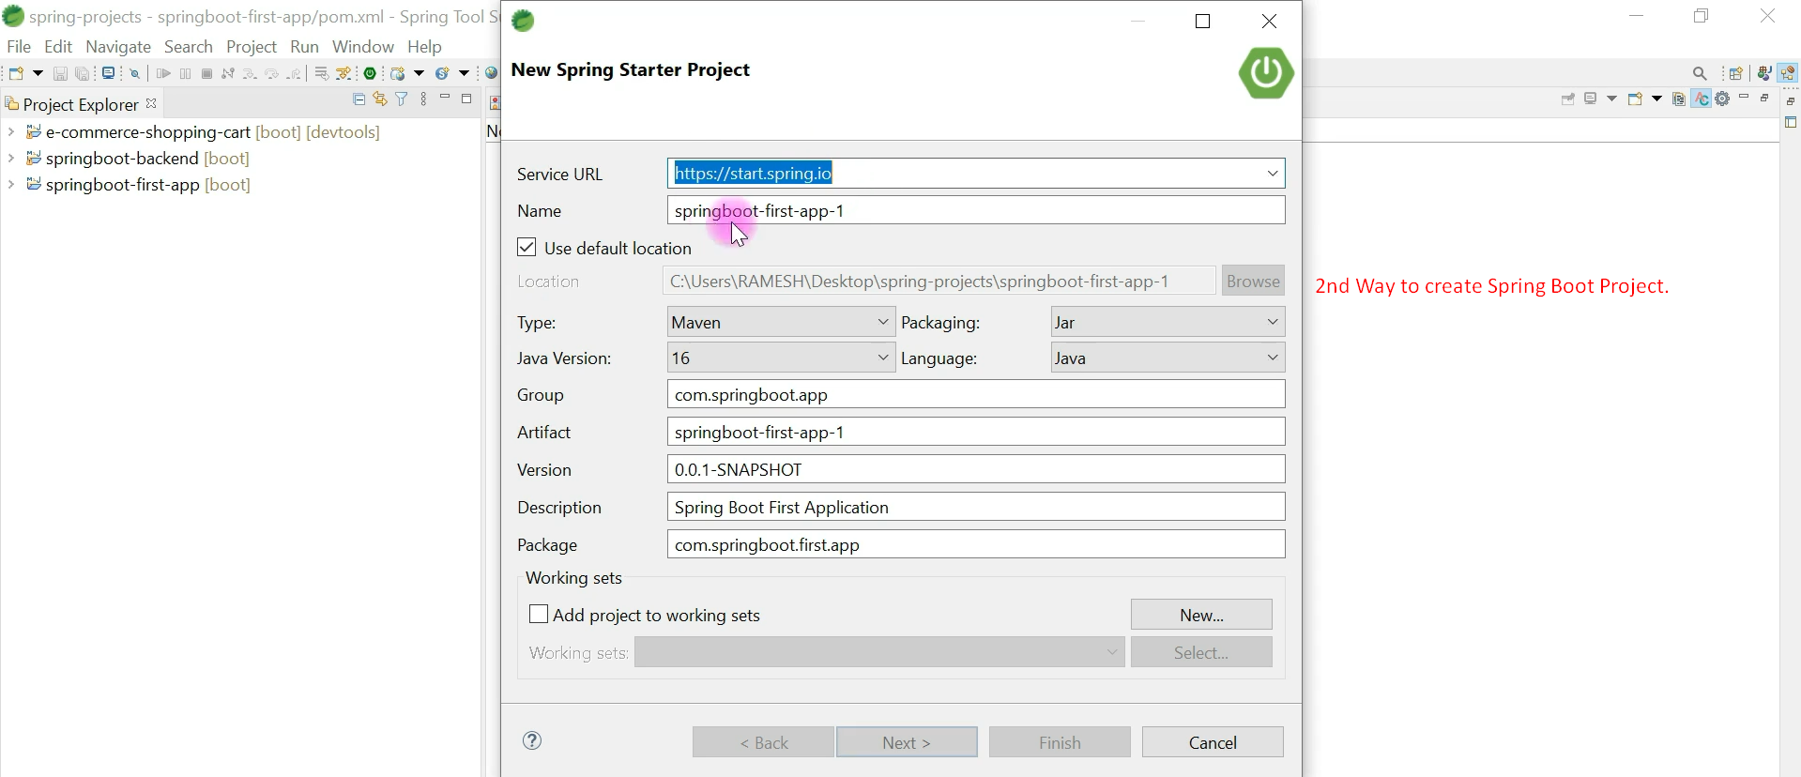
6. 